

**Lab Manual- Develop on Azure Kubernetes Service (AKS) with Helm**

**Prepared for**:

**Date:** 18th Dec 2023

**Prepared by:**

Document Name: Lab Manual **Document Number** AZLabn916

**Contributor:**

Contents

[1. Objective 3](#_Toc155531847)

[2. Create an Azure Container Registry 3](#_Toc155531848)

[3. Download the sample application 3](#_Toc155531849)

[4. Build and push the sample application to ACR 4](#_Toc155531850)

[5. Create your Helm chart 5](#_Toc155531851)

[6. Run your Helm chart 8](#_Toc155531852)

# Objective

[Helm](https://helm.sh/) is an open-source packaging tool that helps you install and manage the lifecycle of Kubernetes applications. Similar to Linux package managers like APT and Yum, Helm manages Kubernetes charts, which are packages of pre-configured Kubernetes resources.

In this lab, you use Helm to package and run an application on AKS.

# Create an Azure Container Registry

az acr create --resource-group Alainzoo --name biphelmacr --sku Basic

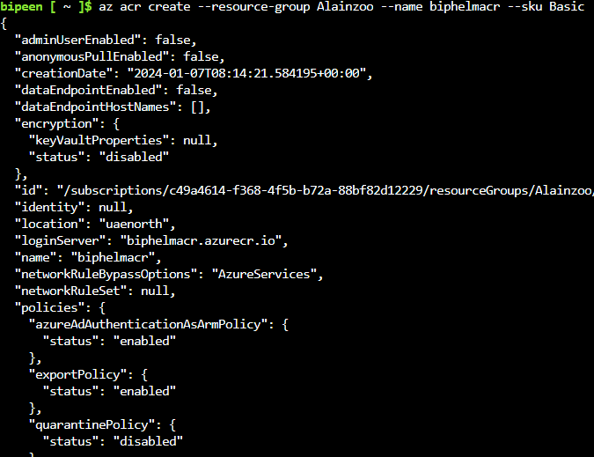

# Download the sample application

git clone https://github.com/bipeensinha/azure-voting-app-redis.git

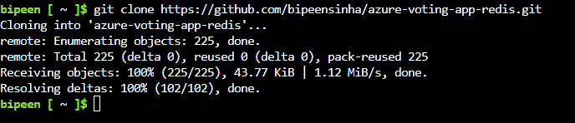

cd azure-voting-app-redis/azure-vote/



# Build and push the sample application to ACR

Build and push the image to your ACR using the [az acr build](https://learn.microsoft.com/en-us/cli/azure/acr" \l "az_acr_build) command. The following example builds an image named **azure-vote-front:v1** and pushes it to the biphelmacr ACR.

az acr build --image azure-vote-front:v1 --registry biphelmacr --file Dockerfile

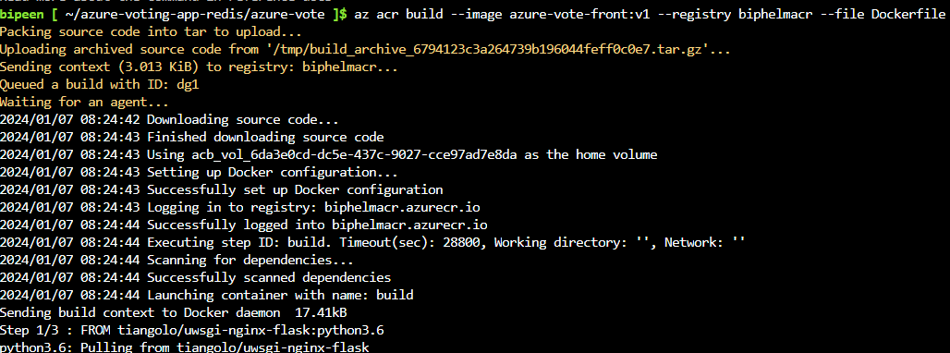

# Create your Helm chart

1. Generate your Helm chart using the helm create command.

helm create azure-vote-front

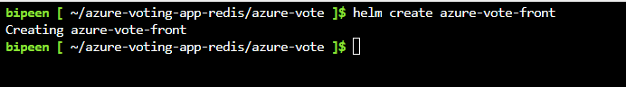

1. List the content of helm chart

ls azure-vote-front

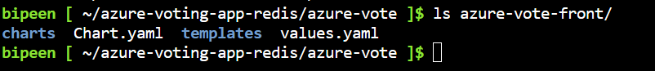

1. Open Chart.yaml in vi editor

vi Chart.yaml



1. Update azure-vote-front/Chart.yaml to add a dependency for the **redis** chart from the **https://charts.bitnami.com/bitnami**chart repository and update appVersion to v1, as shown in the following example:

apiVersion: v2

name: azure-vote-front

description: A Helm chart for Kubernetes

dependencies:

- name: redis

version: 17.3.17

repository: https://charts.bitnami.com/bitnami

...

# This is the version number of the application being deployed. This version number should be

# incremented each time you make changes to the application.

appVersion: v1

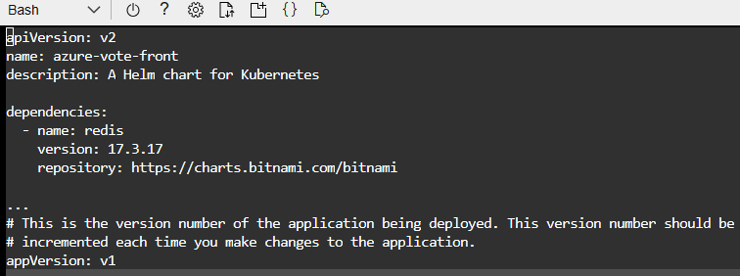

1. Update your Helm chart dependencies using the helm dependency update command.

helm dependency update azure-vote-front



1. Travers inside **azure-vote-front** directory

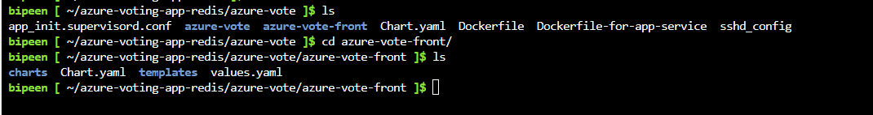

1. Update *azure-vote-front/values.yaml* with the following changes.

* Add a ***redis*** section to set the image details, container port, and deployment name.
* Add a ***backendName*** for connecting the frontend portion to the *redis* deployment.
* Change ***image.repository*** to <loginServer>/azure-vote-front.
* Change ***image.tag*** to v1.
* Change ***service.type*** to *LoadBalancer*.

vi values.yaml



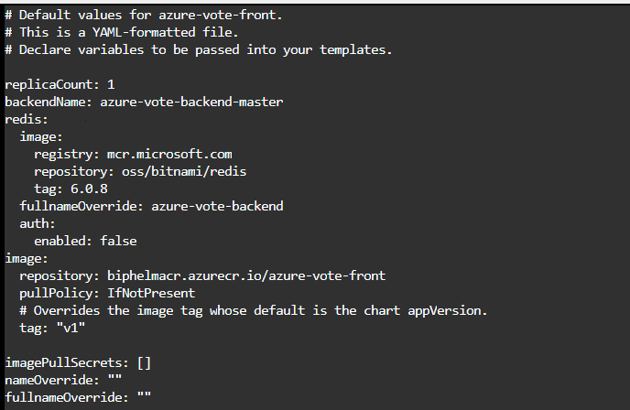

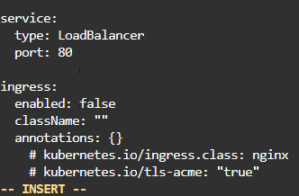

Save and Exit

Add an env section to azure-vote-front/templates/deployment.yaml to pass the name of the redis deployment.

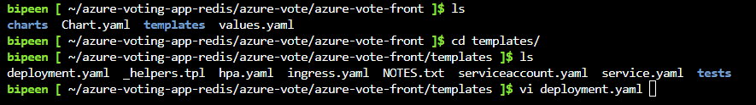

containers:

- name: {{ .Chart.Name }}

securityContext:

{{- toYaml .Values.securityContext | nindent 12 }}

image: "{{ .Values.image.repository }}:{{ .Values.image.tag | default .Chart.AppVersion }}"

imagePullPolicy: {{ .Values.image.pullPolicy }}

env:

- name: REDIS

value: {{ .Values.backendName }}

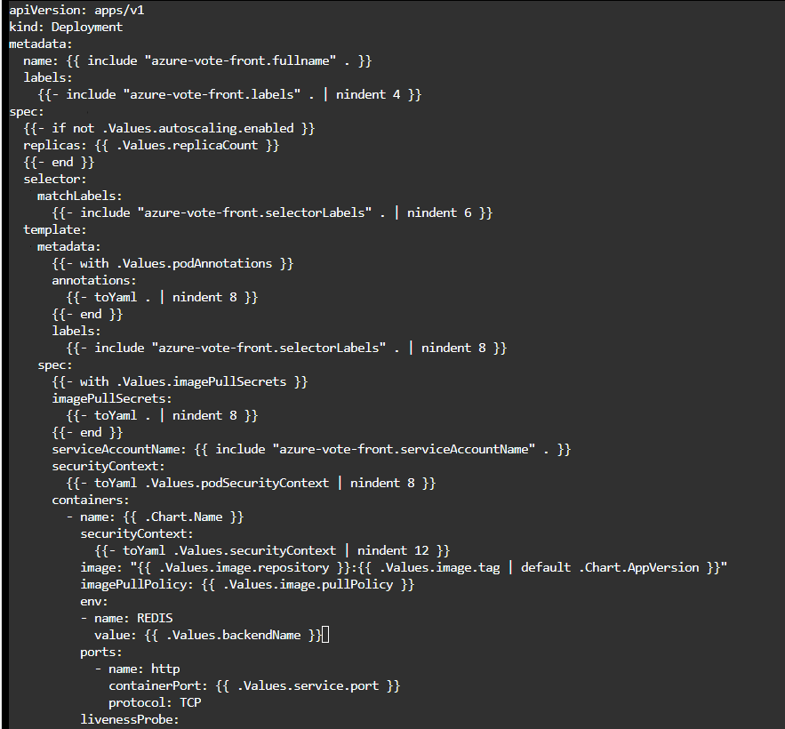

# Run your Helm chart

1. Install your application using your Helm chart using the helm install command.

cd ..

cd ..

helm install azure-vote-front azure-vote-front/

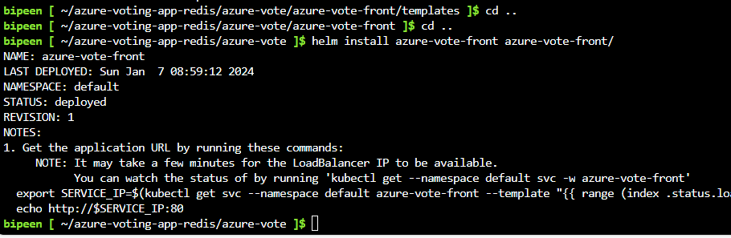

1. It takes a few minutes for the service to return a public IP address. Monitor progress using the kubectl get service command with the --watch argument.

kubectl get pods --watch

kubectl get service --watch

